How to Subscribe to Benton-Franklin Counties Superior Online Court Calendar
- ​To subscribe, click on the following link: Official Website (bentoncountywa.gov) Please enter your name and email address, then select the categories about which you would like to receive notices. Emails are sent out nightly.
- Categories to select to stay informed with Benton and Franklin Counties Superior Court (see yellow highlights):
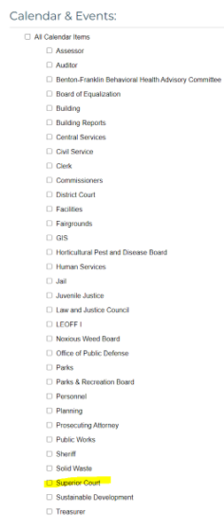
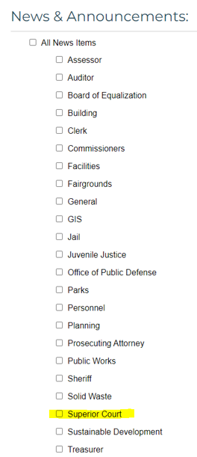

- Link to Calendar: Calendar (bentoncountywa.gov)
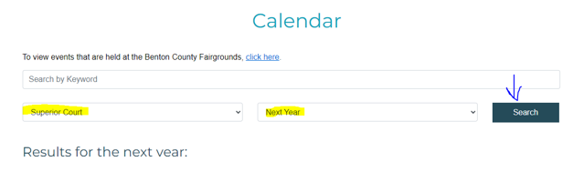
- Example of View:
